**WEB DESIGN**

*Mid Term*

|  |  |
| --- | --- |
| **Course** | Web Design |
| **Exam Type** | **Mid Term** |
| **Duration** | 2 hours |
| **Generation** | GEN-10 |
| **Date** | NOV 20th 2024 |
| **Exam Rules** | * All documents allowed * The following actions are forbidden and will conduct to a 0 score:   + Talking or exchanging information with another student   + Using Internet or any Network |

Evaluation

|  |  |
| --- | --- |
| **Exercise 1** | 20 points |
| **Exercise 2** | 30 points |
| **Exercise 3** | 50 points |

To start

* Read this **document** AND the start **code** (ZIP) from MS TEAM

To submit

* Submit this **document** AND your **code** (ZIP) on MS TEAM

**EXERCISE 1 (20 pts)** *CRITICAL THINKING*

**Q1 – 6 pts**

You need to apply a style to 5 elements on a page.

*Would you* ***use a class, an ID, or a type selector?*** *Justify your choice and explain the potential risks of each method.*

ID is unique and it can cancel out class and type selector style because of it important so I would use to style the item that is important. Class are great at styling a group of item or item inside a container but it is hard to style the inner item with class because you have to be specified with the selector. And lastly type selector are use the style one html syntax like h1 or h2 but it can only style one so it can get repetitive with the style and it doesn’t have an important so other can cancel it out like id

**Q2 – 3 pts**

You are tasked to design a button with an exact width of 100px, including padding and borders.

*Which* ***box-sizing mode*** *should you use,* ***and why****?*

Border-box because it can easily style the button with width or padding or margin inside or outside the box model

**Q3 – 3 pts**

You are creating a photo gallery.

*Would you use* ***Flexbox or Grid for the layout****? Explain your decision, considering alignment, responsiveness, and maintenance.*

Yes, I would use flexbox or grid for the layout because of its responsiveness that you can create with these two. First, I would use grid layout for the 2D plain like create a table or a nav bar and with the content inside each cell I would use flexbox to make the content responsive

**Q4 – 3 pts**

You need to add space between a button and the text above it.

*Should you use margin or padding on the button? Justify your choice.*

I would use margin because it can add space outside of the item like a button and the text that need the space outside of its respective item

**Q4 – 5 pts**

Here is a website folder structure.

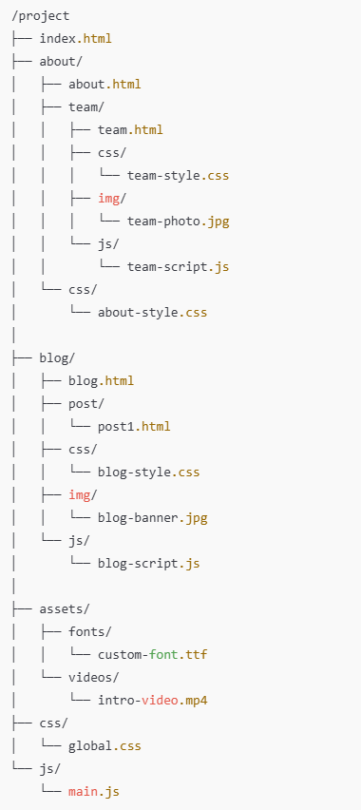

Fill up the table with the **hyperlink**, so that we **can create an anchor link** from the **source folder** to the **destination file**.

|  |  |  |  |
| --- | --- | --- | --- |
| ***PATH TYPE*** | ***SOURCE FOLDER*** | ***DESTINATION FILE*** | ***HYPERLINK LINK*** |
| ABSOLUTE |  | team-style.css | href= “team-style.css” |
| RELATIVE | project/about/team | blog.html | href= “.../blog/blog.html” |
| RELATIVE | project/ blog/css / | team-style.css | href= “../about/team/css/team-style.css” |
| RELATIVE | project/ blog/js / | Global.css | href= “.../css/global.css” |
| ABSOLUTE |  | intro-video.mp4 | href= |

**EXERCISE 2 (30 pts)**

Design the bellow mock up using a **GRID layout**.

**PART 1** *– Main components – 25 pts*

Design the bellow mock up.

* Your need to change both CSS and HTML
* Use the color as the bellow mockup

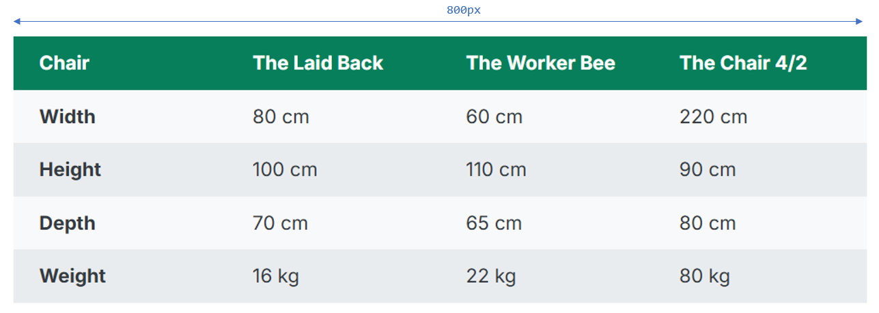

* Each cell should have the same paddings:

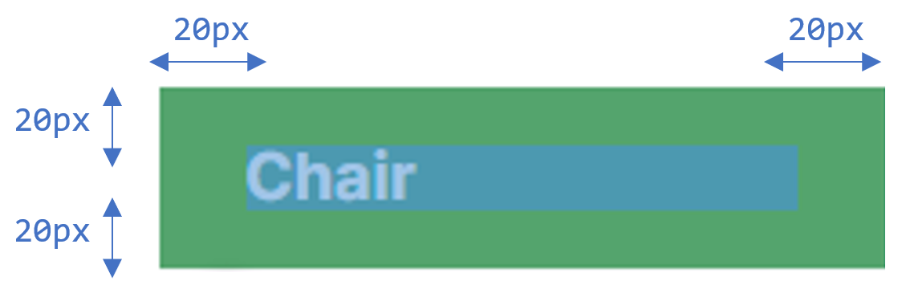

**EXERCISE 3 (50 pts)**

**PART 1** *– Main components – 20 pts*

Design the below mock up using a **GRID layout**. *(No grid layout = no points!)*

* The HTML is provided and **cannot change**.
* *Remaining* means the related row or column **shall stretch** on the available space.

Colors:

* Menu #343a40
* Left Section #7048e8
* Nav #e9ecef

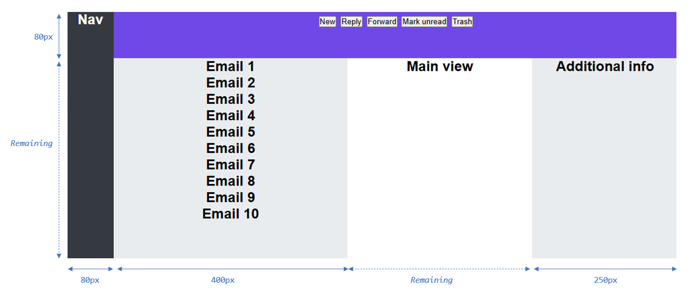

**PART 2** *– Inner elements – 30 pts*

Continue the work by designing the **menu buttons** and **email items**

* Use the types of layouts you want
* Note: the **email section has a scrollbar**: are you able to display it?

Colors:

* Menu button: # 5F3DC4
* Last menu button # d6336c
* Email # adb5bd

